|  |  |  |
| --- | --- | --- |
| spw_mob_infra_signature2.png | Road Safety Regulation and Road Control Directorate  Exceptional transport unit  Boulevard du Nord, 8 - 5000 Namur  Tél : 0032 (0)81 77 24 00 - Mail : [te@spw.wallonie.be](mailto:te@spw.wallonie.be) | |
| **NOTE: Fill out the announcement form**  **for support companies** | |

Any support provided in Belgium must be announced in advance (see the note on the announcement of support).

Each recognised company authorised to accompany an exceptional transport in Belgium receives a unique URL on which it can announce the planned support.

How this ad works:

There is a test version of the form available by clicking on the following link:

<https://docs.google.com/forms/d/e/1FAIpQLSf9rVPx85U3LovNv98DO6m-5GjsMwBPiTof1L6nTSpt4RFBUg/viewform?usp=sf_link>

The effective link is personally transferred to the recognised support company.

This link already contains a few pre-filled fields. We can customize this on request (you often work for the same transport company and you want to indicate a "standard" carrier, or you always arrive at the same address, ...). Only the email address cannot be pre-filled.

In the first question section, general information is requested about your business.

* **Email address: The email address mentioned is the address to which the proof of listing will be sent;**
* **The company** making the announcement**:** Normally, this should not be changed. But by changing this, you can sign up for a colleague. If this is not done in consultation, it can be considered fraud;
* **Phone number**: The phone number where the police can reach you during transit. This can be either the general number of the dispatch or the mobile number of the accompanying person;
* **Authorization Number**: The authorization number that is used for the starting point of the route;

In the second section, transport-specific data are requested.

* **The type of authorization**: Check the box for your authorization;
* **Other permission(s**): You can use multiple permissions for a route. For example: *a Route* permission from the starting point to the network and then follow the network with a *Network*  permission;
* **Police assistance**: Make a choice. If yes, name the police department that provides the assistance;
* **The company that carries out the transport**: The company that is mentioned as the "*User*" in the authorization;
* **Departure date**: Make sure to make the announcement in time (see the table of departure times in the note *announcing an accompaniment*);
* **Addresses**:
  + Place of departure – arrival of the transport (municipality – city): the municipality or city of departure or arrival;
  + Place of departure – arrival of the transport (Street name + dock number or number or road number + Border or geographical coordinates)
    - Street name + number: *e.g.: Rue de l'Eglise 15*
    - Quay number (in ports): *e.g.: Quay 482*
    - Road number + Border: e.g. *A3 German border*
    - Coordinates: *e.g.: 50.708633, 4.099048*
      * Via Google maps: place yourself on the destination, right-click and choose "*More info about this place*". You will then see a screen with the contact details. You can copy them to the form.

The third section will only have to be completed when an internship is carried out during the accompaniment (cf. the training of a type 2 accompaniment, *Article 13 of the Decree of the Walloon Government of 8 September 2022 on the accompaniment of exceptional vehicles*).

If you submit the form, you will immediately receive an email with your answers. You still have the option to adjust your answers, after which you will receive a new email.

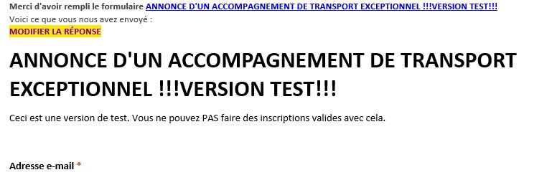

If you forward this email, the recipient will have the opportunity to adapt your reply. The recipient by this email will also be able to retrieve your unique link and therefore make announcements on your behalf.

In order to avoid this, when forwarding the mail please delete this link as follows:

1. Click Transfer;
2. Select and delete "EDIT RESPONSE";
3. Send your email

Suppose you suspect that your unique link has been passed on to third parties or you want to change the link due to a change in personnel, ...

* Contact [te@spw.wallonie.be](mailto:te@spw.wallonie.be);
* We will then check with you if any false reports have been made and correct the list;
* We will provide you with a new unique link.